

WinMan REST API

Installation Guide
Version: 2.0.0 By Lynn Eagleton

Contents

Overview 2
Prerequisites 3
Requesting a DNS entry 4
Obtaining the application files 5
Instructions for members of Support 5
Instructions for members of Development (Birmingham) 5
Installing the API 7
Activating the UI Screens 11
Activating the REST API Scopes 13

Overview

The WinMan REST API makes it possible for developers to integrate web-based systems with WinMan. The API makes WinMan data accessible over HTTPS using OAUTH2 authentication/authorisation, keeping data secure. It can provide and accept both JSON and XML formatted data.
The current version of the API is geared towards eCommerce website integration, and as such, the endpoints which are available allow developers to retrieve data for:
- Products.
- Products Attachments (e.g. image and PDFs).
- Product Stock Levels.
- Product Categories.
- Customers.
- Price Lists.
- Customer Delivery Addresses.
- Customer Sales Orders.
- Customer Sales Invoices.
- Customer Statements,
- Customer Account Overviews.
Developers can also send data back to WinMan for:
- New Sales Orders.
- New Customers.
- Converting a Quote to a Sales Order.
Endpoints can be purchased separately.
A single installation of the WinMan REST API allows developers to communicate with two separate WinMan databases, typically one Live and one Training. If more than two databases exist, multiple installations of the WinMan REST API will be required to communicate with them. This is covered in more detail in the Prerequisites section of this document.
If the customer’s databases are for different versions of WinMan, separate installations of the WinMan REST API should be installed for each database, otherwise, the API may behave unexpectedly due to incompatibilities between the databases and the API codebase.
This document covers the installation of version 2.0.0 of the WinMan REST API and is aimed primarily at members of Support.

Prerequisites

The following conditions must be met on the customer’s WinMan server for WinMan to carry out the installation. If any are missing, you should liaise with the customer and/or their third-party IT support provider to ensure the necessary work is carried out.
- WinMan v7.0098.31. If the customer is running an older version of WinMan, you should arrange an upgrade with them.
- NodeJS v6.11.2. More recent versions of NodeJS may be compatible but have not yet been tested. This should be installed by the customer’s IT support provider and requires a server restart to complete the installation. The installer is available at https://nodejs.org/en/download/releases/.
- The customer’s WinMan server must be accessible over HTTPS. This may require port forwarding rules to be set up by the customer’s IT support provider. The relevant port(s) should also be opened on the customer’s router. You can check to see if the relevant ports are open by using a simple online tester, such as https://www.yougetsignal.com/tools/open-ports/. Simply enter the customer’s external IP address and your port number, click the Check button, and you will see a message telling you whether the port is open or closed.
- A valid DNS entry. This should be set up by Mike at WinMan.

A single installation of the WinMan REST API gives developers access to data from two WinMan applications, typically Live and Training. This runs as a Windows Service and should typically be made accessible via port 3000. The Windows Service name should be set as something like winman-rest-api.
If the customer has multiple WinMan applications, the WinMan REST API will need to be installed multiple times on the WinMan server. Subsequent installations of the API should typically be made available via sequential ports, and the Windows Service names should be appended with some unique identifier (e.g. winman-rest-api-usa, winman-rest-api-eu etc.).
WinMan comes with two programs which relate to the API: Rest API Users and Ecommerce Websites. By default, these two programs are not enabled, so must be manually activated during the installation process. Detailed instructions for how to do this are included in the Activating the UI Screens section of this guide.

Requesting a DNS entry

In order for the WinMan REST API to be accessible to developers, a valid URL must exist. To set this up, you should request a new DNS entry from Mike. To carry out the work, Mike will need the following information:
- The desired URL. This should be of the format [customername]rest.winman.net. For example, talkingtablesrest.winman.net.
- The external IP address of the server. This can be obtained through the LogMeIn client. Simply click on the information icon underneath the customer’s server name to reveal the server details:
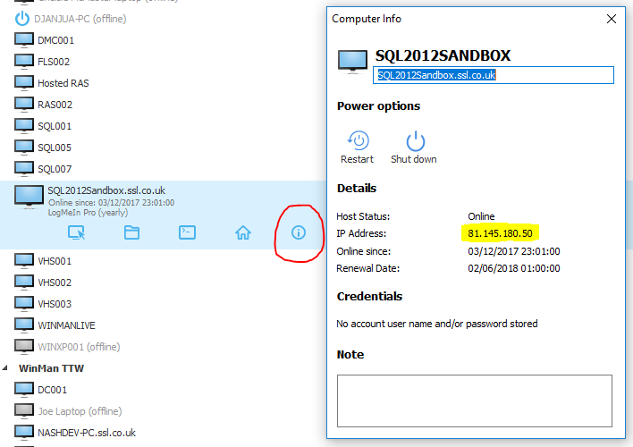
Alternatively, you can log on to the customer’s server, open a web browser and perform a Google search for the term what’s my IP?. The first result will be the customer’s external IP address, for example:
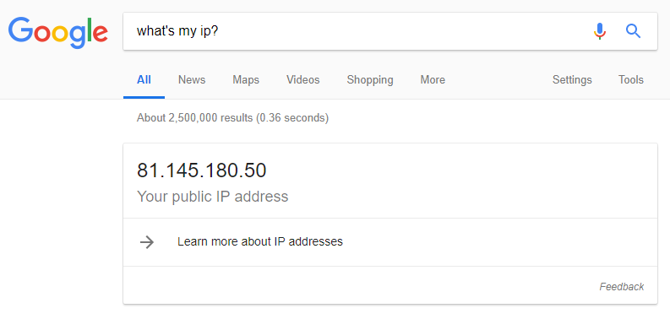

Obtaining the application files

Instructions for members of Support
Members of WinMan Support should obtain the WinMan REST API application files from a member of the Development Team (Birmingham). You should provide the following information for each installation that is to be carried out when you request the files:
- The service name. For example, winman-rest. Please keep the name winman in this service name instead of the customer’s name.
- The display name for the service. This is simply a more user-friendly version of the service name which will be visible in the list of Windows services on the customer’s server. For example, WinMan REST API. This name will also be displayed in several places in the API Portal. As such, please keep the name WinMan in this display name instead of the customer’s name.
- SQL server connection information. This should be provided for each database the API will connect to (e.g. both Live and Training).
  - SQL server name. If the API is being installed on the same server as the SQL server, this can be set to localhost.
  - SQL server instance name. For a large proportion of WinMan’s customers, this will not be applicable as the customer uses the default instance.
  - Username. A username which can be used to log on to the SQL Server.
  - Password. The password for the above username.
  - Database name. This will usually be something like Winman or Training.
  - Reports server username. A username which has access to the customer’s WinMan reports server. This is necessary as some of the API’s endpoints return PDFs from the reports server which requires NTLM authentication.
  - Reports server password. The password for the above username.
- The API URL. This will be the DNS entry which was set up by Mike. For example, rest.winman.net.
- The API port number. This will usually be 3000 for the first installation on the customer’s server, 3001 for the second and so on.

Instructions for members of Development (Birmingham)
Members of the Development Team (Birmingham) should build the API package using the Node Package Manager (npm). In a command prompt, cd into the root of the WinMan REST API repository and issue the following command to build the package. Please note that this command is case-sensitive.
npm run build
This will copy all the necessary files into the dist folder. During this process you will be asked to enter the information provided by Support on the command line. For each question that is presented, you can enter ? if you wish to view a help message. If you accidentally enter the wrong information, you will need to manually edit the generated config file in the dist/config folder, or re-run the build command and enter the information again.
Once you have completed the above, you can provide Support with the contents of the dist folder. You may find it easiest to place contents of the dist folder in a ZIP file before sending to Support.

Installing the API

Once you have obtained the application files, you can commence installation. Follow the steps below:
- Open a file manager window in the LogMeIn client by clicking on the file manager icon underneath the customer’s server name:
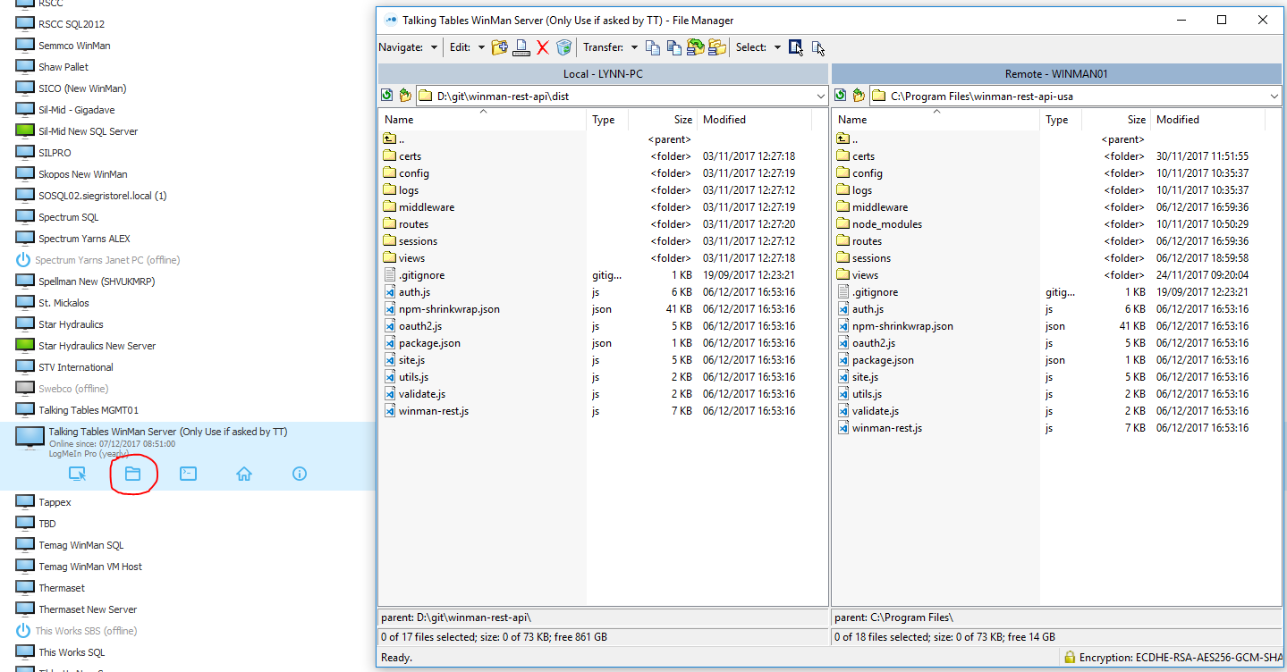
In the file manager window, you will see your PC in the left pane and the customer’s server in the right pane. In the left pane, navigate to the location which contains the application files. If you have a ZIP file, you will need to extract its contents first. In the right pane, navigate to a suitable location (e.g. C:\WinManV7) and create a new folder with a suitable name (e.g. winman-rest-api). Highlight all the application files in the left pane and click and drag them into the new folder in the right pane.
Alternatively, if you are using a Remote Desktop connection instead of LogMeIn, you can log on to the customer’s server, create the necessary folder (e.g. C:\WinManV7\winman-rest-api), and then drag and drop (or copy and paste) the application files from your computer onto the server.
- Open a command prompt window in the LogMeIn client by clicking on the command prompt icon underneath the customer’s server name:
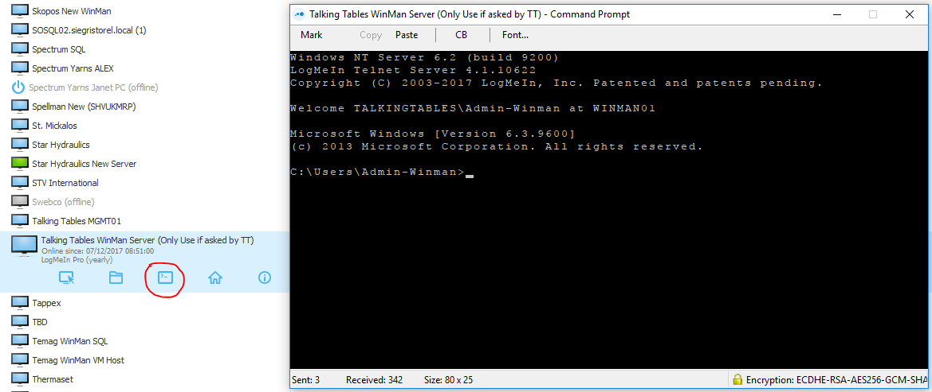
Type the following and press enter. Please note that this command is case-sensitive.

npm install --global --production windows-build-tools
This command will take approximately 5-10 minutes to complete. After it has completed, type the following and press enter. Please note that this command is case-sensitive.
npm install --global node-gyp
This command will take approximately 1-2 minutes to complete.

Alternatively, if you are using a Remote Desktop connection instead of LogMeIn, you should type the above commands in an elevated Command Prompt window (i.e. run as administrator). To do this, log on to the customer’s server, click on the Windows button in the bottom-left corner of the screen and type command prompt. Right-click on the result labelled Command Prompt and click Run as Administrator. Once the command prompt window has opened, you can type the two commands listed above.

- Log on to the customer’s server to create two new environment variables. To do this, once logged on, click the Windows button in the bottom-left corner of the screen and type environment variables. Click on the result labelled Edit the system environment variables, which will bring up a small properties window. In this window, click the button labelled Environment Variables. You should now see a window similar to the following:

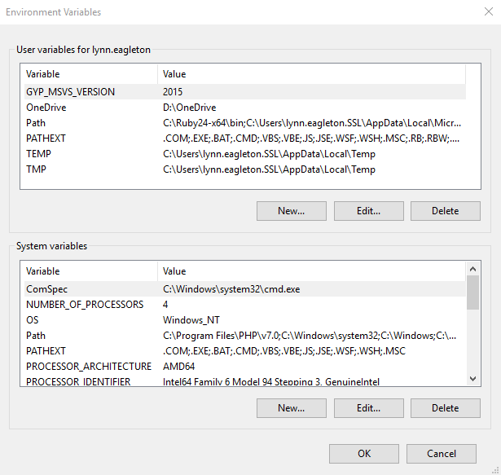
Click the bottom button labelled New… to create a new system environment variable.

There are two variables to create, the first of which defines the location of the Python executable. You should enter the following information and click OK when done:

Variable name: PYTHON
Variable value: C:\Users\<username>\.windows-build-tools\python27\python.exe

You should change <username> to match the username you logged on to the server with, for example Admin-Winman.

The second variable defines the mode which NodeJS runs in on the server. You should enter the following information and click OK when done:

Variable name: NODE_ENV
Variable value: production

Next, you should close and reopen your command prompt window so that the new environment variables take effect. If you are using a Remote Desktop connection instead of LogMeIn, remember to open your command prompt window using the Run as Administrator option. In your new command prompt window type the following and press enter. Please note that this command is case-sensitive.
cd /d "C:\WinManV7\<folder name>"
You should replace <folder name> with the name of the folder you created in step 1. You may also need to change C:\WinManV7\ if you created the folder in a different location.

Next, type the following and press enter. Please note that this command is case-sensitive.
npm install
This may take 5-10 minutes to complete.

In order for the API to be available all the time, it needs to be run as a Windows service. To set this up, in your command prompt window type the following and press enter. Please note that this command is case-sensitive.
node winman-rest --add
If the service is added successfully, you should see a message which says something like WinMan REST API service successfully added.

Finally, you can start the service. Type the following and press enter. Please note that this command is case-sensitive.
net start "<service name>"
You should replace <service name> with the actual service name, e.g. winman-rest.
If the service is started successfully, you should see a message which says something like The WinMan REST API service was started successfully.

The API is now installed, but before a developer can access any information, some data must be added within the WinMan application. Instructions on what to add and how to add it can be found in the WinMan REST API v2.0.0 User Manual.

Also, the relevant programs and REST API Scopes in WinMan must be activated. The next two sections of this document explain how to achieve this.

Activating the UI Screens

After installing the API, you should ensure that the necessary programs are enabled in the WinMan application, namely Rest API Users and Ecommerce Websites. These two programs are disabled by default, so if either of these programs do not appear in WinMan when you search for them, you will need to manually activate them in the database. To do this, follow the steps below:
- Whilst logged on to the customer’s server via LogMeIn or Remote Desktop, open SQL Server Management Studio and connect to the customer’s SQL Server.
- Click the New Query button to open a new query editor window, and then select the correct database (e.g. Winman or Training) from the databases drop-down menu:
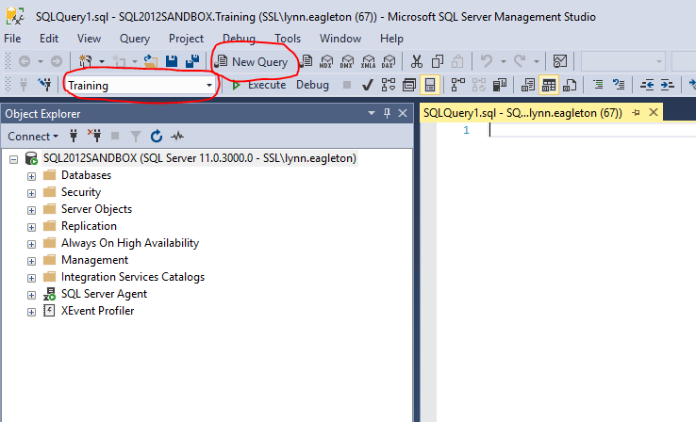
In your query editor window, enter the following SQL query:
UPDATE
Programs
SET
Display = 1
WHERE
Program IN ('EcommerceWebsites', 'RestAPIUsers');
Click the Execute button to execute the query. After executing, the Messages window below your query editor window should state that 2 rows were affected:
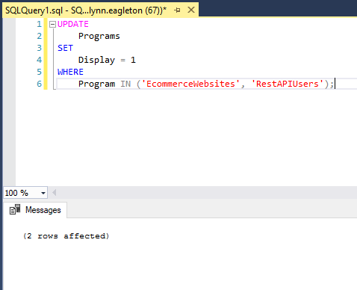
- Open the relevant WinMan application (close and re-open if you already had it open) and search for the Rest API Users and Ecommerce Websites programs again. They should now appear as normal.

Activating the REST API Scopes

REST API Scopes can be thought of as permissions. For example, the scope getCustomers allows developers to fetch customer data from WinMan to use on a website, and the scope postSalesOrders allows developers to send new sales order data back in to WinMan from a website.
REST API Scopes match up to endpoints which can be purchased separately, so they are not included in the WinMan database as part of a patch or major release and instead must be added manually upon installation.
The SQL query below can be used to add all the scopes which are currently available in the standard version of the API. You should amend this query to suit the customer’s needs:
IF NOT EXISTS(SELECT RestApiScope FROM RestApiScopes WHERE RestApiScopeId = 'getCustomerPriceLists')
BEGIN
INSERT INTO RestApiScopes (RestApiScopeId, [Description]) VALUES ('getCustomerPriceLists', 'allows read access to customer price lists');
END;
IF NOT EXISTS(SELECT RestApiScope FROM RestApiScopes WHERE RestApiScopeId = 'getCustomers')
BEGIN
INSERT INTO RestApiScopes (RestApiScopeId, [Description]) VALUES ('getCustomers', 'allows read access to customers');
END;
IF NOT EXISTS(SELECT RestApiScope FROM RestApiScopes WHERE RestApiScopeId = 'postCustomers')
BEGIN
INSERT INTO RestApiScopes (RestApiScopeId, [Description]) VALUES ('postCustomers', 'allows write access to new customers');
END;
IF NOT EXISTS(SELECT RestApiScope FROM RestApiScopes WHERE RestApiScopeId = 'getProductAttachments')
BEGIN
INSERT INTO RestApiScopes (RestApiScopeId, [Description]) VALUES ('getProductAttachments', 'allows read access to product attachments');
END;
IF NOT EXISTS(SELECT RestApiScope FROM RestApiScopes WHERE RestApiScopeId = 'getProductCategories')
BEGIN
INSERT INTO RestApiScopes (RestApiScopeId, [Description]) VALUES ('getProductCategories', 'allows read access to product categories');
END;
IF NOT EXISTS(SELECT RestApiScope FROM RestApiScopes WHERE RestApiScopeId = 'getProductInventories')
BEGIN
INSERT INTO RestApiScopes (RestApiScopeId, [Description]) VALUES ('getProductInventories', 'allows read access to product inventories');
END;
IF NOT EXISTS(SELECT RestApiScope FROM RestApiScopes WHERE RestApiScopeId = 'getProducts')
BEGIN
INSERT INTO RestApiScopes (RestApiScopeId, [Description]) VALUES ('getProducts', 'allows read access to products');
END;
IF NOT EXISTS(SELECT RestApiScope FROM RestApiScopes WHERE RestApiScopeId = 'postSalesOrders')
BEGIN
INSERT INTO RestApiScopes (RestApiScopeId, [Description]) VALUES ('postSalesOrders', 'allows write access to new sales orders');
END;
IF NOT EXISTS(SELECT RestApiScope FROM RestApiScopes WHERE RestApiScopeId = 'getDeliveryAddresses')
BEGIN
INSERT INTO RestApiScopes (RestApiScopeId, [Description]) VALUES ('getDeliveryAddresses', 'allows read access to customer delivery addresses');
END;
IF NOT EXISTS(SELECT RestApiScope FROM RestApiScopes WHERE RestApiScopeId = 'getSalesOrders')
BEGIN
INSERT INTO RestApiScopes (RestApiScopeId, [Description]) VALUES ('getSalesOrders', 'allows read access to sales orders');
END;
IF NOT EXISTS(SELECT RestApiScope FROM RestApiScopes WHERE RestApiScopeId = 'getAccountOverviews')
BEGIN
INSERT INTO RestApiScopes (RestApiScopeId, [Description]) VALUES ('getAccountOverviews', 'allows read access to customer account overview information');
END;
IF NOT EXISTS(SELECT RestApiScope FROM RestApiScopes WHERE RestApiScopeId = 'getStatements')
BEGIN
INSERT INTO RestApiScopes (RestApiScopeId, [Description]) VALUES ('getStatements', 'allows read access to customer statements');
END;
IF NOT EXISTS(SELECT RestApiScope FROM RestApiScopes WHERE RestApiScopeId = 'getInvoices')
BEGIN
INSERT INTO RestApiScopes (RestApiScopeId, [Description]) VALUES ('getInvoices', 'allows read access to customer invoices');
END;
IF NOT EXISTS(SELECT RestApiScope FROM RestApiScopes WHERE RestApiScopeId = 'getPdfs')
BEGIN
INSERT INTO RestApiScopes (RestApiScopeId, [Description]) VALUES ('getPdfs', 'allows read access to PDF printouts');
END;
IF NOT EXISTS(SELECT RestApiScope FROM RestApiScopes WHERE RestApiScopeId = 'putConvertQuotes')
BEGIN
INSERT INTO RestApiScopes (RestApiScopeId, [Description]) VALUES ('putConvertQuotes', 'allows write access to convert quotes to orders');
END;
Once the scopes have been added to the database, they can be assigned to eCommerce Websites to enable developers to start using the API. Instructions on how to do this can be found in the WinMan REST API v2.0.0 User Manual.

